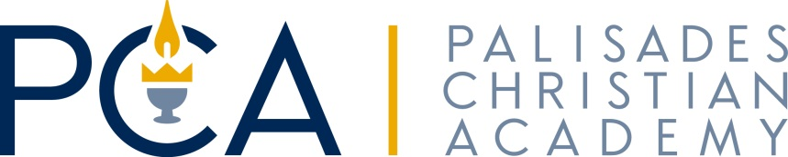

Dear Sponsor,
On Sunday, January 26, 2020, Palisades Christian Academy will be hosting its 20th Annual Benefit Auction. Palisades Christian Academy strives to provide top academics, excellent music instruction, invigorating athletics and to foster community involvement in a nurturing, Christ-focused environment.
As in the past, the success of our fundraiser exclusively depends on the contributions from generous sponsors, like you, who graciously donate various items to our auction. We would like to invite you to support this endeavor through your donation. This year the auction, as in the past, proceeds will be focused on Student Success.
We invite you to showcase your business and your commitment to our community with a donation.
Contribute an item(s) or service(s) and be acknowledged in our auction catalog and on our school auction website. Please note that any gift certificate with an expiration date should be valid for one year from the date of the auction – January 26, 2020.
In order for your sponsorship contributions to be recognized and included in our auction catalog, the enclosed donation form must be received by January 20, 2020. Palisades Christian Academy is a 501(c) (3) organization so gifts are eligible for tax deduction. Upon receipt of your gift, we will send you a thank you letter with our tax identification number to serve as your receipt for tax purposes.
You may contact us to make pick up arrangements for your donation or mail it directly to our address below. Please contact us by phone or email with any questions you may have.
On behalf of the faculty and students of PCA, we thank you in advance for your generous donation. We are so grateful for your support!

Sincerely,
Monte Fisher, PCA Principal
1115 N. Government Way, Spokane, WA 99224
(509) 325-1985
www.pcasda.org
Jessica Terry, PCA Auction Coordinator
(509) 540-1615
Jess12terry@gmail.com

